High and Low Range Comparison
In previous sections, we look at the high range and low range instruments isolated and compared their recordings against each other. We did this primarily to determine trends, consistencies, and inconsistencies in the data. In our comparisons, we found that some of our open E string harmonic recordings exhibited super-sonic behavior while some did not. We also saw that the open G string recordings varied widely as expected, since the open G string is anecdotally considered to be a good “tell” of a quality violin.
In this section, our goal is to compare instruments across varying price ranges to determine what objective measures from the data can be used to determine if one instrument is of higher quality than another. We’ll be looking at the same instruments and same recordings from previous section, but this time, we’ll be comparing high price instruments against low price instruments. Specifically, we’ll be looking at the Kono and one of the Kutz #100 violins.
First, we’ll look at the open G string recordings for these two instruments. The harmonic intensity plots for these two recordings can be seen in Figure 1.

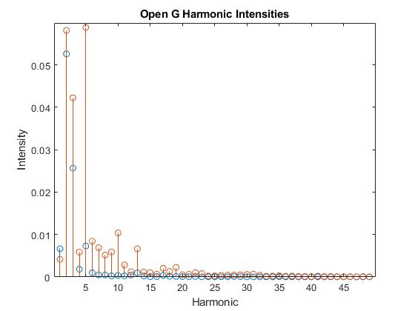
Figure 1: Open G Harmonic Intensities
The plot of the harmonic intensities of the open G recording for the Kono and Kutz #100 can be seen above, with the Kono in blue and the Kutz in orange. The peak for the Kono occurs at the second harmonic and is distinct, followed by an exponential decay in the upper harmonics. The Kutz, however, has its maximum harmonic intensity at the fifth harmonic. Not only is its peak later, but the Kutz also has a similar but slightly weaker peak in the second harmonic. Like the Kono, it follows an exponential decay, but the decay on the Kutz’s spectrum is much noisier. From this, we can say that higher quality instruments may have a cleaner and more well-defined harmonic spectrum on the G string, as opposed to lower quality instruments having a much noisier lower spectrum.
Next, we’ll look at the open E string recording for both instruments. The harmonic intensity plot for these recordings can be seen in Figure 2.

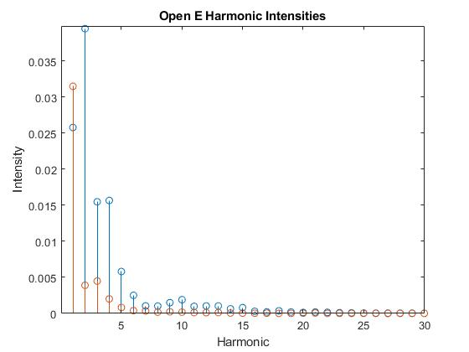
Figure 2: Open E Harmonic Intensities
The plot for the harmonic intensities for the E string can be seen above, again with the Kono in blue and the Kutz in orange. The peak harmonic for the Kono occurs at the second harmonic, while the peak harmonic for the Kutz occurs at the first harmonic. After the peaks, both instruments follow an exponential decay; the decay on the Kono is slightly noisier than the decay on the Kutz. The Kono also consistently has stronger harmonic intensities than the Kutz, normally by about a factor of 3. From this, we can take away in general that for the E string, higher quality instruments will have stronger upper harmonics, while lower quality instruments’ upper harmonics will die out faster. It should be noted that both recordings had a completely inactive ultrasonic spectrum. This may be attributed to variations in the recording process.
Next, we’ll look at the open G harmonic recordings. The frequency spectrum for these recordings can be seen in Figure 3.

